Format of Question paper for Midsemester Examination

Birla Institute of Technology & Science, Pilani
Work Integrated Learning Programmes Division
Second Semester 2024-2025

Makeup Examination
(EC-2 Makeup)

Course No. : AIMLCLZG513
Course Title : Advanced Deep Learning
Nature of Exam : Closed Book
Weightage : 30%
No. of Pages = 2

No. of Questions = 4
Duration :
Date of Exam :
Note to Students:
- Please follow all the Instructions to Candidates given on the cover page of the answer book.
- All parts of a question should be answered consecutively. Each answer should start from a fresh page.
- Assumptions made if any, should be stated clearly at the beginning of your answer.

Q.1. [3+5=8 Marks]
You are training a hypothetical autoencoder with:
- Input layer: 2 units
- Hidden layer: 2 neurons
- Output layer: 2 units
- Hidden activation function: Sigmoid
- Output activation: Linear
- Sparsity constraint: 0.2
- Input (real valued) and weights:
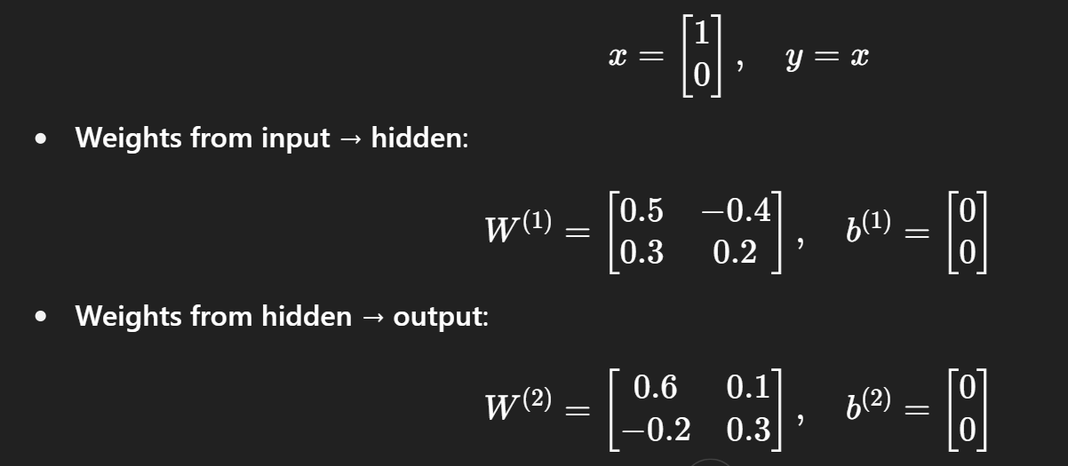
- If no sparsity constraint is used, and linear activation were used in hidden layer, what will be the value of W⁽¹⁾ and W⁽²) after training is over? What will be the value of loss function after training? Assume weights can be 1 or 0 only, and bias is kept at 0.
- If sparsity constraint is used, calculate the weight matrix W⁽¹⁾ after one iteration. Assume learning rate=0.15. Show all steps clearly for partial marking.

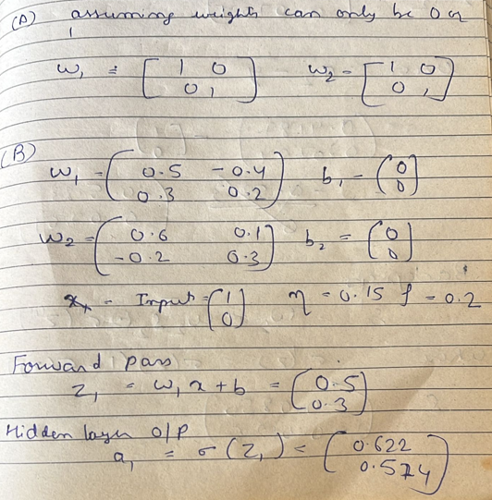
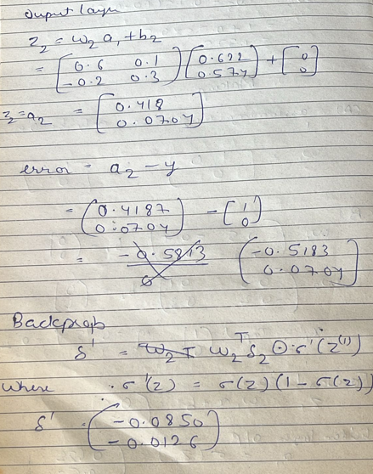

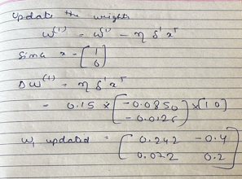

Q.2. [2+3+2=7 marks]

- In a RealNVP flow model, given an input vector x=[2 3]^{T},
- what will be the value of transformed output vector y?
- Calculate the log determinant of the Jacobian.

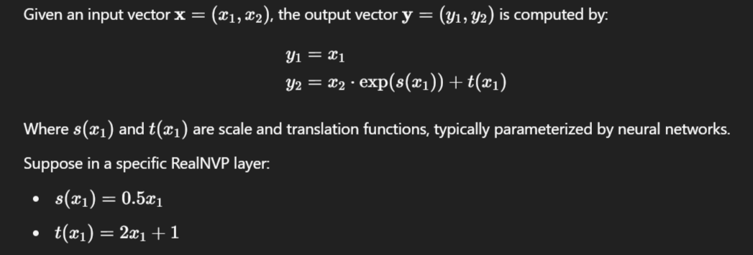

- What type of masking patterns are used in RealNVP for implementing variable partitioning? What is the purpose of masking in RealNVP?
Checkerboard mask: Used for image data (e.g., alternating pixels in a 2D grid).
Channel-wise mask: Used for channel dimensions in image tensors (e.g., mask half the channels).
To ensure all variables are eventually transformed, the mask is alternated (e.g., flipped) between layers. This way, different subsets of the input are transformed in different coupling layers.

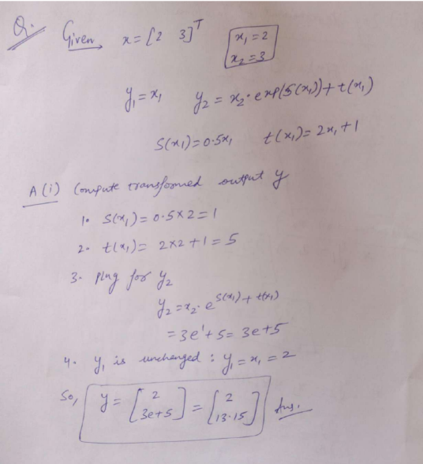

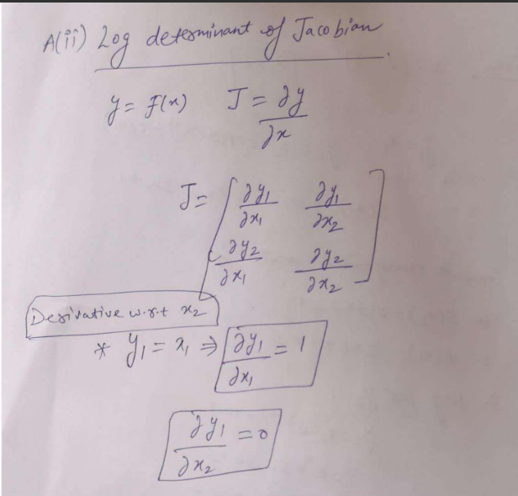

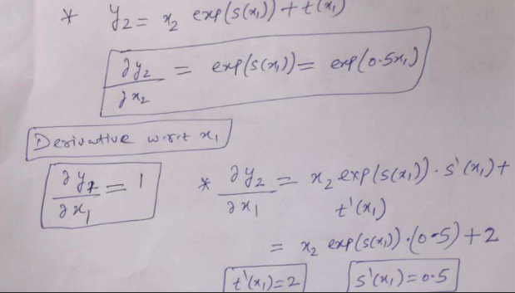

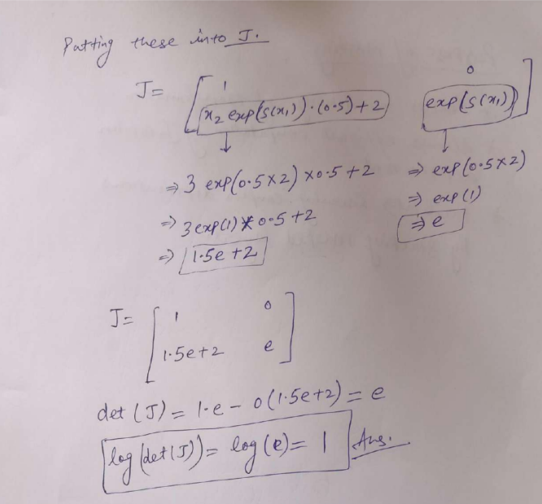

Q.3. [3+1+2+1+2=9 marks]

- What is the computational complexity of i) standard PCA, ii) randomized PCA and iii) kernel PCA for N training instances of dimension d.
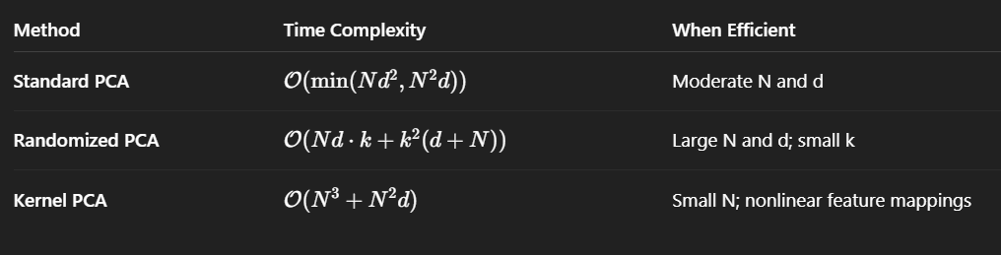
- What is one application of independent component analysis (ICA)?
Signal separation
- What are the key architectural elements of Gated PixelCNN? What is the utility of each of these elements?
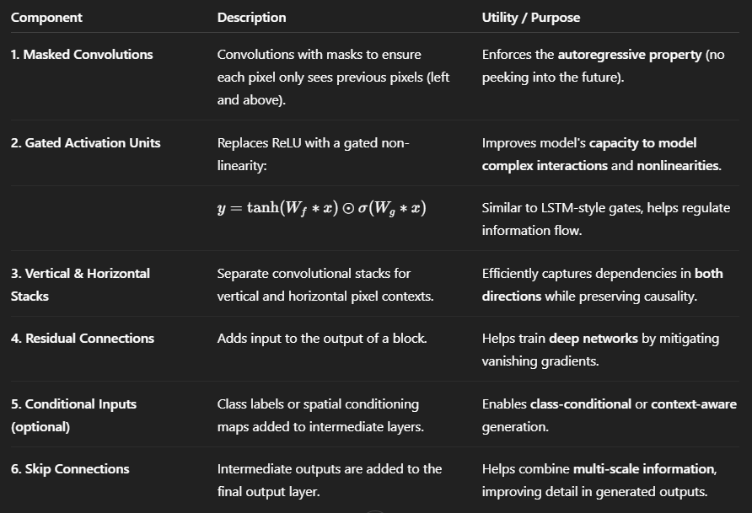

- PDF of a random variable x is given by normal Gaussian distribution. What is the probability of x=0?
0
- How is dequantization done in flow models? Why is it needed?
Dequantization is done by adding uniform random noise between 0 and 1 to the input data. It is needed since flow models are inherently developed for continuous data, yet most real-world datasets (like images) are made of discrete values, typically integers (e.g., 0–255 for each RGB channel). Directly modeling discrete data using flows causes issues because:
- Continuous density models will assign infinite likelihood to discrete points (they try to squeeze the probability mass into singular points).
- Log-likelihoods become unbounded or undefined.
Q.4. [2+2+1+1=6 Marks]

- Assume a trained MADE is used to calculate p(x₁), p(x₂|x1), p(x₃|x₂, x₁). x_{t} is the data value at time t, i.e., x1 arrives first, then x2, and x3 at last. Clearly show the steps for generating a new data instance (x1’, x2’, x3’). Assume x1, x2 and x3 are binary valued.
- What are the pros and cons of using more masks in MADE?
- Which version of PixelCNN generates the best receptive field?
- How does parallel Wavenet alleviate the drawback of Wavenet?

- To generate a new data instance (x₁′, x₂′, x₃′) using a trained MADE (Masked Autoencoder for Distribution Estimation) model, we need to follow the autoregressive factorization of the joint distribution:
p(x)=p(x₁) . p(x₂ ∣ x₁) . p(x₃ ∣ x₁, x₂)
MADE achieves this factorization by using masks in a feedforward neural network to ensure the correct conditional dependencies are respected (i.e., ensuring that output neuron for x_{t} only depends on inputs x_{<t}
Given that the variables are binary (x_{i} ∈ {0,1}), MADE outputs the Bernoulli probability 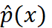= p (x_{i}=1 ∣ past inputs), and we can sample from that probability to generate each x_{i}` ​.
We assume:
- The MADE model has already been trained on some binary data.
- During inference (sampling), we x1′, x2′, x3′​ in order, feeding earlier sampled values as inputs to generate the next.

Step 1: Sample x₁′ from p(x₁)
- Input to MADE: x = [0,0,0] or a placeholder vector.
- Due to the mask, the output neuron for x₁ does not depend on any inputs (because x₁∼ p(x₁)).
- MADE outputs = p(x₁=1).
- Sample:
x₁′ ∼ Bernoulli( )

Step 2: Sample x₂′ from p (x₂ | x₁′)
- Input to MADE: x=[x₁′,0,0]
- The output neuron for x₂​ depends only on x₁′ due to masking.
- MADE outputs = p(x₂=1∣x₁′).
- Sample:
x₂′ ∼ Bernoulli ()

Step 3: Sample x₃′ from p (x₃ | x₁′, x₂′)
- Input to MADE: x = [x₁′, x₂′,0]
- The output neuron for x₃​ depends only on x₁′, x₂′​.
- MADE outputs 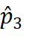= p(x₃=1 ∣ x₁′, x₂′).
- Sample:
x₃′∼ Bernoulli ()

Final Output
x′ = [x₁′, x₂′, x₃′]]
This is one sample from the learned distribution p(x), with the autoregessive dependencies enforced via masking in the MADE network.
- MADE is an autoregressive model that uses masking in a neural network to enforce a particular variable ordering, so that the output variable x_{i}​ depends only on previous variables x_{<i}​. To achieve generalization across different orderings and improve performance, MADE can be trained using multiple masks (i.e., different orderings of variables).

Pros of Using More Masks in MADE
- Better Generalization
Multiple masks prevent the model from overfitting to a single variable ordering. This encourages the model to learn shared structure across orderings, leading to better generalization.
- Order-Agnostic Learning
Allows the model to become less sensitive to the specific ordering of input variables, which is important in domains where no natural ordering exists.
- Improved Likelihood Estimation
Averaging likelihoods over multiple orderings (inference-time ensembling) often leads to lower perplexity and better density estimation.
- Increased Robustness
Randomizing masks introduces stochasticity during training, functioning as a regularizer that improves model robustness.
- More Expressivity
The model implicitly learns to approximate a richer set of conditional distributions by being exposed to more orderings.

Cons of Using More Masks in MADE
- Higher Training Time
Generating new masks and computing forward passes with different orderings increases training time, especially if masks are resampled frequently.
- Implementation Complexity
Managing multiple masks and ensuring correct gradient flow requires more complex code and careful mask handling, especially in deep networks.
- Noisy Gradients
Frequent mask resampling introduces gradient noise, which might slow down convergence or make training unstable unless carefully managed (e.g., with batch normalization or learning rate schedules).
- Memory Overhead
Training with multiple masks may require storing more intermediate activations or recomputing parts of the graph, which increases memory usage.
- Inference Complexity (if ensembling)
If you use multiple masks during inference (i.e., ensemble over masks for final prediction), it increases the computational cost at inference time.

- PixelSNAIL

- Parallel WaveNet was introduced to alleviate a major drawback of the original WaveNet: slow autoregressive inference.

Drawback of Original WaveNet
- WaveNet is an autoregressive model:
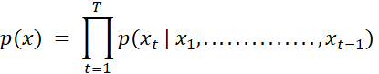
- Each sample x_{t}​ must be generated one at a time, conditioned on all previous samples.
- This makes inference extremely slow, especially for tasks.

How Parallel WaveNet Alleviates This

Key Idea: Distillation + Non-Autoregressive Sampling
Parallel WaveNet replaces autoregressive sampling with parallel, feedforward generation using a method inspired by knowledge distillation.

Steps in Parallel WaveNet
- Train a teacher model (original autoregressive WaveNet).
  - Train teacher model (MAF) via MLE
- Train a parallel student model (called Inverse Autoregressive Flow, or IAF), to minimize KL divergence with teacher, which:
  - Takes as input a latent noise vector z.
  - Uses a feedforward flow to generate the whole waveform in parallel
- Use Probability Density Distillation (PDD) to ensure the student’s output distribution matches the teacher’s.
- Test-time: Use student model for testing
- Improves sampling efficiency over original Wavenet (vanilla autoregressive model) by 1000x!
Components
- Inverse Autoregressive Flow (IAF):
  - A type of normalizing flow that allows parallel sampling but autoregressive density estimation.
- Distillation Loss:
  - Minimizes KL divergence between student and teacher distributions.

